The 30-Minute AI Commercial Challenge: The Aura Beans
Demo Video for reference: Creating AI Commercials with Free Tools.mp4
Welcome, AI Director!
Your Mission: To produce the definitive "Magical Morning" commercial for "Aura Beans," precisely following your final storyboard and asset list.

Your Toolkit:
- Asset Creation: Nano Banana using https://gemini.google.com/ (To create your four foundational, high-quality still images)
- Video & Audio Generation: Veo using “Google Flow” https://labs.google/fx (To animate your scenes and bring your character to life)
- Final Assembly: CapCut / Canva (Where we will use editing and sound to complete the magic)
Alternate Tools ( If access unavailable in you region for Flow ) :
- https://www.krea.ai/ or https://hailuoai.video/ or https://wan.video/
- Eleven Labs for Voiceover/sound affects
- Suno for Background Music

Concept
The ad begins by showing a character's frustrating, low-energy morning, starting with a hated alarm clock. Her day is magically transformed when a bag of "Aura Beans" coffee supernaturally appears on her table, turning her exhaustion into a moment of pure, blissful energy with the very first sip.

Workflow
Step 1 : Create your Blueprint
Step 2 : Create your Assets using Master Director Framework
Step 3 : Animate your Scenes
Step 4 : Final Cut and Showcase

Master Director Framework (Asset Creation) :
[Subject] +[Action] + [Environment] + [Camera] + [Lens] + [Lighting] + [Style].

Director’s Cheat Sheet (Prompt Building Cheat Sheet): Click here
A mix-and-match list of professional filmmaking vocabulary that helps beginners create more predictable and high-quality AI-generated content

Part 1: The Director's Plan
The Concept: A character's frustrating morning is magically transformed by the sudden, wondrous appearance of "Aura Beans" coffee, leading to a moment of pure bliss.
Fill out your final Shot Plan Matrix below.
Asset/Shot | Storyboard Scene | Key Element to Capture | Best Tool (Nano Banana or Veo?) | Why this tool?
Asset 1 | N/A | The Character: Our consistent actor. | Nano Banana | To create a high-quality, reusable character reference.
Asset 2 | N/A | The Dining Table: Our clean "stage." | Nano Banana | To create the environment before and after the magic.
Asset 3 | N/A | The Coffee Bag: Our "hero" prop. | Nano Banana | To generate a perfect, detailed product image.
Asset 4 | N/A | The Alarm: The source of conflict. | Nano Banana | To have a clear, static image of the object of frustration.
Shot 1 (Video) | Scene 1 | The Frustrating Start | Veo (Image-to-Video) | To animate the first action and set the mood.
Shot 2 (Video) | Scene 2 | The Reveal & Reaction | Veo (Image-to-Video) | To establish the character's exhaustion at the table. & To create the magical appearance and the character's shift to curiosity.
Shot 3 (Video) | Scene 3 | The Blissful Reward | Veo (Image-to-Video) | To deliver the final satisfying sip and the all-important tagline.

Part 2: Asset Creation with Nano Banana
We will now generate the five pillars of our commercial. Precision here is key.
Login to Gemini ( https://gemini.google.com/ ) for Free Access to Nano Banana
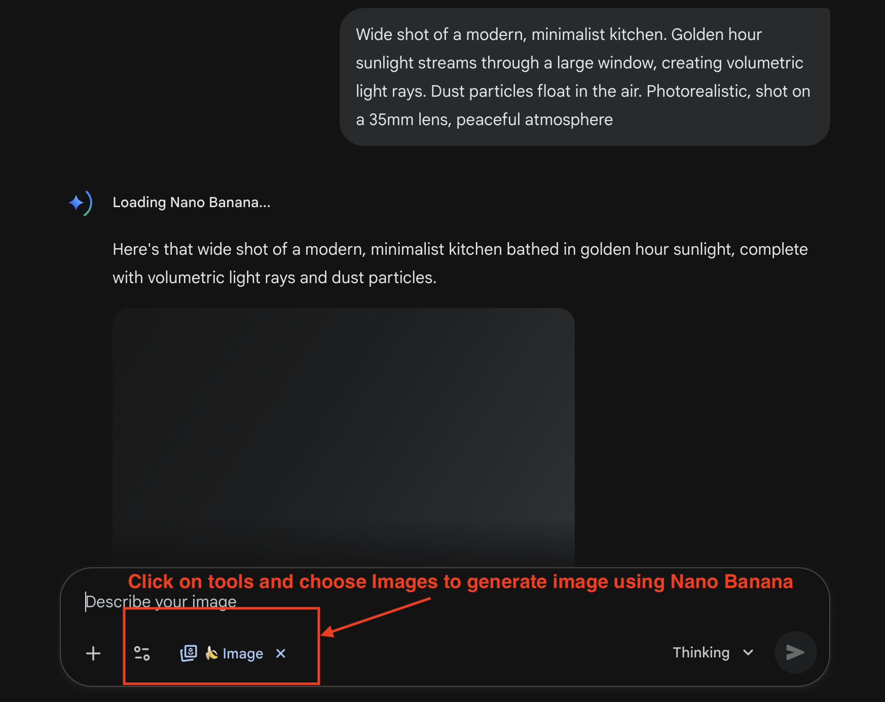
Task 1: The Character (Asset 1)
- Prompt: Photorealistic medium shot of a woman in her late 20s with slightly messy brown hair, wearing simple grey pajamas. She has a tired but neutral expression. She is standing against a plain, light grey background, studio lighting.
- Save the image. This is your "actor."
Task 2: The Dining Table (Asset 2)
- Prompt: Wide shot of an empty, clean wooden dining table in a modern kitchen. Soft, dim morning light is coming from a window on the left. The scene feels quiet and still. Photorealistic.
- Save the image. This is your "set."
Task 3: The Coffee Bag (Asset 3)
- Prompt: Commercial product photography of a premium coffee bag labeled "Aura Beans." Minimalist matte white bag with an elegant, glowing gold foil logo. Shot against a plain white background. Studio lighting.
- Save the image. This is your "hero prop."
Task 4: The Coffee Bag on the Dining Table (Asset 4 - Can be skipped)
- Upload image of the dining table and coffee bag generated in previous steps and prompt as below
- Prompt: The coffee bag on the dining table.
- Save the image. This is your "Bag on Table."
Task 5: The Alarm (Asset 5)
- Prompt: Eye-level shot of a modern digital alarm clock on a wooden nightstand. The time reads 6:00 AM. The background is a blurry, dark bedroom. Photorealistic.
- Save the image. This is your "antagonist."

Part 3: Directing the Story with Omni Flash
Let's animate your scenes in sequence.
Login to Google flow ( https://labs.google/fx/tools/flow) and click on”New Project” to generate videos.
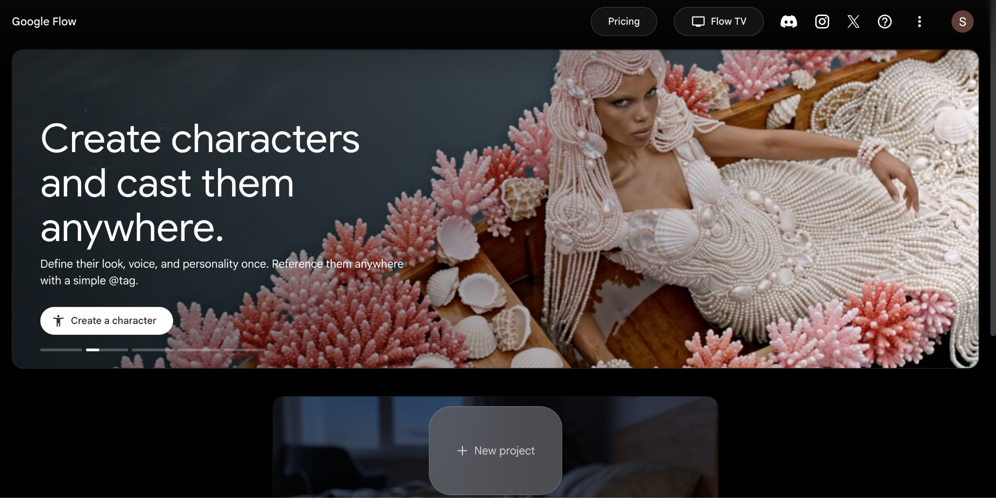
Before you generate: turn on Agent Settings
Open the Agent Settings panel in Flow and set “Confirm before generating” to “Always.” This makes Flow pause and show you the credit cost before every generation, so you never spend your free credits by accident. Keep the other defaults as shown below.
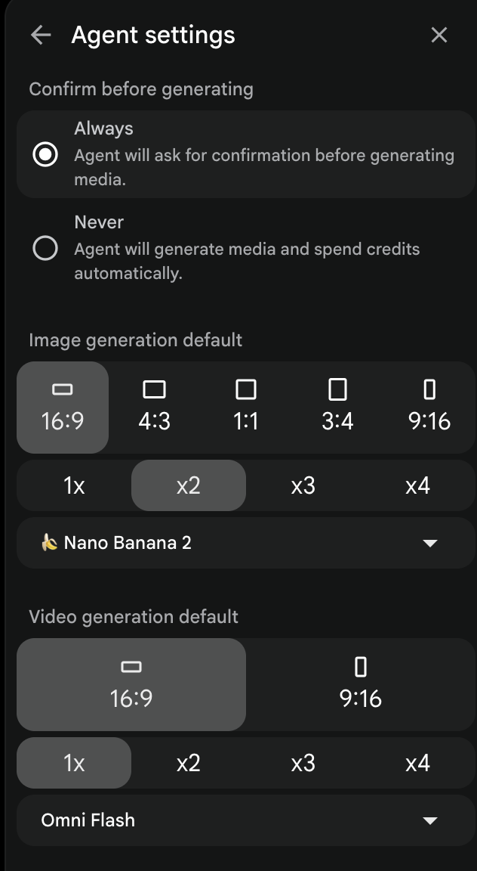
Flow > Agent Settings. Set “Confirm before generating” to “Always” before you start.
Task 6: Scene 1 - The Alarm (Video 1)
- Open Veo and upload your Alarm image (Asset 5).
- Prompt: A hand suddenly enters the frame from the right and slams down on top of the alarm clock. The motion is fast and frustrated.
- Generate the video.
Task 7: Scene 2 - The Reveal & Reaction (Video 2)
- Director's Note: We use a "jump cut" here. We cut to her already at the table. This is a standard filmmaking technique.
- In Veo, upload your Coffee Bag image (Asset 3) , your Dining Table image (Asset 2) and Character image (Asset 1)
- Prompt: The coffee bag (Image 1) instantly appears in the center of the dining table (Image 2) , while the tired woman is slumping over the dining table. The moment it appears, a bright spotlight from above illuminates it, and magical light particles swirl around it for a second.
- Generate the video.
(If Only ) Out of credits? Switch to a second account
- You have now generated two videos, so your free credits may be running low. Flow’s free plan provides approximately 50 credits, and each video consumes roughly 15 credits. If your credits (or tokens) are used up, open Google Flow in a different Chrome profile signed into another Google account and continue there - each account gets its own free credits.
Task 8: Scene 3 - The Blissful Reward (Video 3)
- Director's Note: We imply Scene 3 (making the coffee) by cutting directly to the result.
- In Veo, use your Character image (Asset 1) and The Coffee Bag on the Dining Table (Asset 4) and Coffee Bag (Asset 3)
- Prompt:
[0-3s] The woman holds a full coffee mug, taking a long, satisfying sip. [3-5s] She leans back with a happy, relaxed sigh, a warm smile on her face. [5-8s] She looks directly into the camera and says: "Aura Beans. Pure morning magic." Audio: A happy sigh, the sound of a mug placing down, warm ambient noise.
- Audio Generation is auto enable with Veo 3.1
- Generate your final shot.

Part 4: Final Cut & Showcase
This is where the real magic happens. The edit will sell your story.
- Download: Save all your video clips from Veo.
- Assemble in CapCut / Canva : Place the clips in the correct order on your timeline.
  - Clip 1: The Alarm
  - Clip 2: The Reveal & Reaction
  - Clip 3: The Blissful Reward
For this workbook we will consider Canva ( https://www.canva.com/video-editor/ )
Navigation Steps : Canva > Create > Search for Video in the search Bar > Choose video Landscape
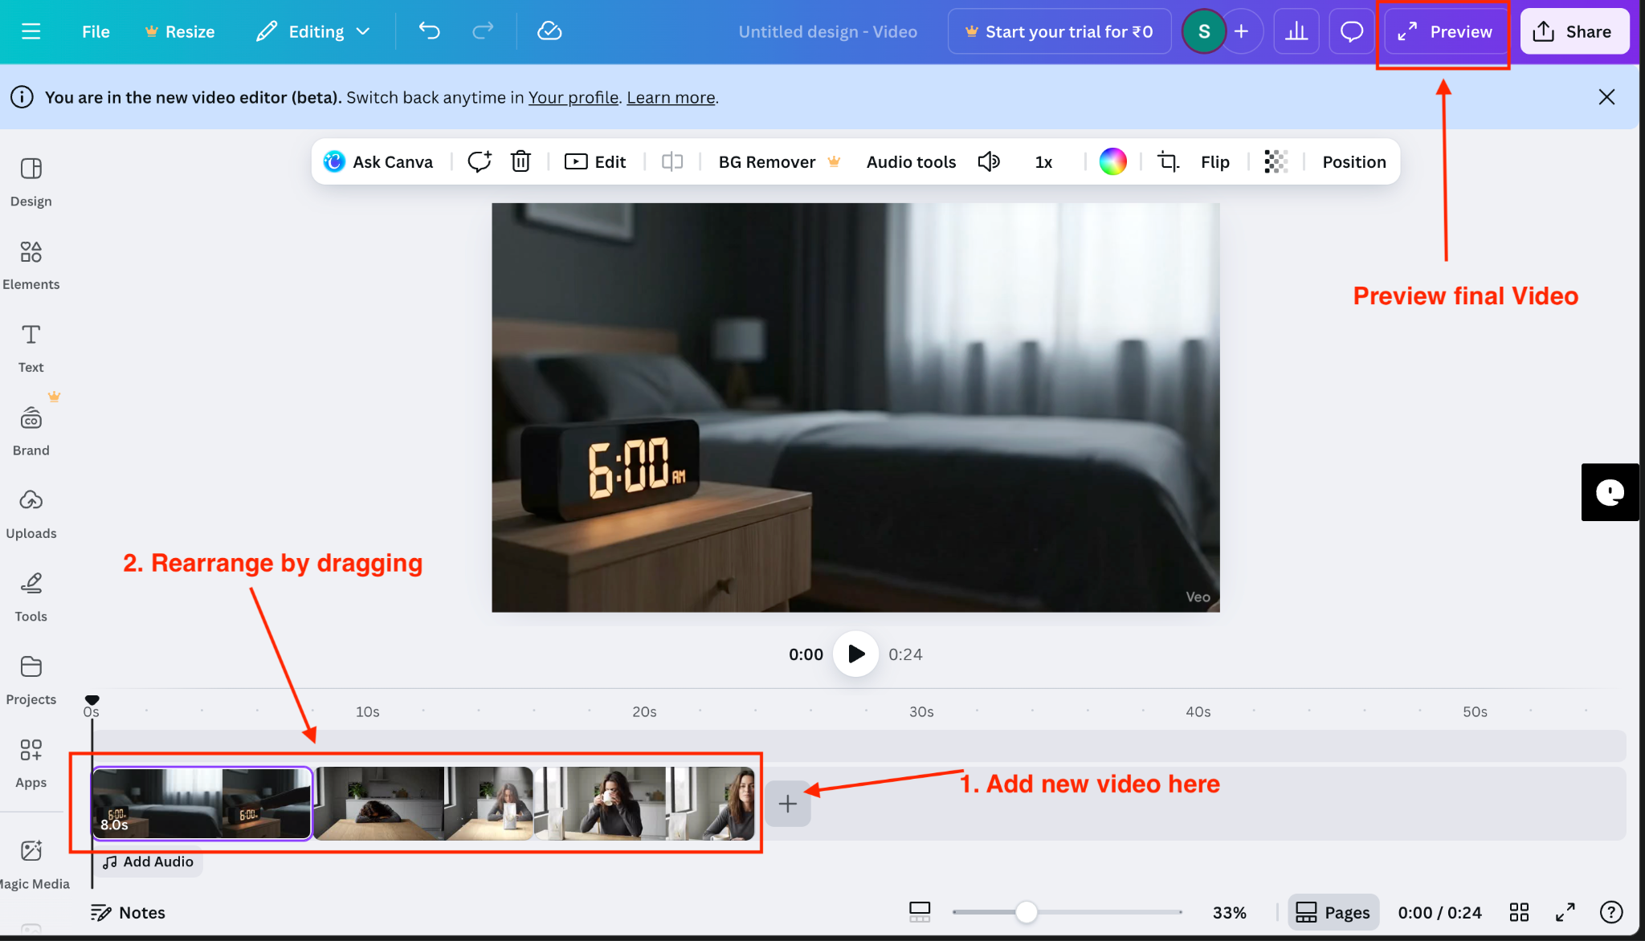

- CRITICAL SOUND DESIGN (Optional):
  - At the exact moment the coffee bag appears (start of Clip 3), add a "WHOOSH" and a soft "THUMP" sound effect. This is what sells the idea of it dropping into place.
  - Add a subtle, magical-sounding music track underneath the entire commercial.
- Export: Save your final commercial.
Congratulations, Director!

APPENDIX: PATH TO PROFESSIONAL (Paid Tools)
Note: You completed this strictly with free tools. If you were doing this for a paying client (Slide 6 Matrix), here is how the stack would upgrade:
For Character Consistency: Midjourney (Higher fidelity).
For Complex Motion: Kling Pro or Runway Gen-3 (Better physics than Veo).
For Lip Sync: ElevenLabs (Voice) + HeyGen (Sync) provides professional lip-sync accuracy.
For Resolution: Topaz Video AI (To upscale your 720p generation to 4K broadcast quality).

